Contents

**11. Human Creativity** 2

**11.1.** **Myths About Creativity** 3

**1.** **The smarter you are, the more creative you are.** 3

**2.** **The young are more creative than the old.** 3

**3.** **Creativity is for flamboyant risk takers.** 4

**4.** **Creativity is a solitary act.** 4

**5.** **You can’t manage creativity.** 5

**11.2.** **Three Components of Individual Creativity** 5

**11.2.1.** **Expertise** 6

**11.2.2.** **Creative Thinking Skills** 7

**11.2.3.** **Motivation** 7

**11.3.** **Managing for Greater Individual Creativity** 8

**11.3.1.** **Tips for Increasing Your Own Creativity** 9

**11.3.2.** **Summing Up** 10

**12.** **Working Through Creative Groups** 11

**12.1.** **Characteristics of Creative Groups** 11

**12.1.1.** **Signs That Your Group Lacks Diversity** 12

**12.1.2.** **The paradoxical characteristics of creative groups** 12

**12.2.** **Divergent and Convergent Thinking** 13

**12.2.1.** **Tips for Improving Convergent Thinking** 14

**12.3.** **Diverse Thinking Styles** 15

**12.4.** **Diversity of Skills** 16

**12.4.1.** **Tips for Filling Team Gaps** 16

**12.5.** **Conflict in Groups—and How to Handle It** 17

**12.6.** **Three Steps for Handling Creative Conflict** 18

# **11. Human Creativity**

*The Starting Point of Creativity*

**Key Topics Covered in This Chapter**

*•Creativity and the creative process*

*•Myths and realities*

*•The components of individual creativity: expertise, flexible and imaginative thinking, and motivation*

*•Managing for creative output*

EARLIER CHAPTERS OF this book focused on the front end of the innovative process: idea generation, opportunity recognition, and the processes that companies use to choose between many innovative ideas and move them to- ward commercialization. Very little was said, however, about the creativity from which ideas and innovations emerge, or about the things that managers can do to encourage it. We turn to these here and in chapter 12. But first, let’s examine the concept of creativity and some popular misconceptions about it.

The English word *creativity*has its source in the Latin *creatus*, to have grown. It refers to the human act or process of producing a new idea or approach to a problem. Innovation follows in the train of a creative idea—that is, innovation is the process that applies the creative idea to development of a useful product, service, process, business model, or practice. Thus, creativity is the starting point of innovation.  What goes on in creativity? Many have tried over the decades to answer this question. Perhaps one of the most useful was formulated by Graham Wallas in his 1926 work, *The Art of Thought*, where creativity was described as a four-stage process of:

**•Preparation:**The individual’s mind perceives the problem and explores its dimensions

**•Incubation:**The problem enters the unconscious mind (as many say,

“I’m sleeping on it”). Synthesis of the bits and pieces of the problem no doubt occurs during this stage

**•Illumination:**The Aha! moment

**•Verification:**The stage in which the creativity idea is consciously verified, elaborated, and eventually applied¹.

Understanding the stages of this process will help you to better under- stand the creativity that is happening around you.

## **Myths About Creativity**

Quite a bit of research has been done on creativity over the years. This re- search indicates misconceptions that limit the ability to effectively manage it. Five such misconceptions are described below.  **Myth #1: The smarter you are, the more creative you are.** *Reality*: Intelligence correlates with creativity only to a point. Once you have enough intelligence to do your job, the correlation no longer holds. That is, above a fairly modest threshold—an IQ of about 120—there is no correlation between intelligence and creativity. As we will see later, there is no valid profile for the creative person; nor is there a test for determining a person’s creative powers. So be careful about using IQ tests, grade point averages, and similar measures as you screen the people you look to for creative thinking.

### **The smarter you are, the more creative you are.**

*Reality*: Intelligence correlates with creativity only to a point. Once you have enough intelligence to do your job, the correlation no longer holds. That is, above a fairly modest threshold—an IQ of about 120—there is no correlation between intelligence and creativity. As we will see later, there is no valid profile for the creative person; nor is there a test for determining a person’s creative powers. So be careful about using IQ tests, grade point averages, and similar measures as you screen the people you look to for creative thinking.

### **The young are more creative than the old.**

*Reality*: Age is not a clear predictor of creative potential. Research shows that it usually takes seven to ten years to build up deep expertise in a given field—the kind of expertise that enables a person to perceive patterns of order or meanings that are invisible to the novice. Thus, in the business world, the necessary creativity can be found in an adult of any age. At the same time, however, expertise can inhibit creativity: experts sometimes find it difficult to see or think outside established patterns. So when you think about staffing R&D or product development teams, think about creating a balance of veterans and newcomers. The veterans have deep expertise; the minds of newcomers are not contaminated by conventional thinking.

### **Creativity is for flamboyant risk takers.**

*Reality*: A willingness to take calculated risks does play a role in creativity. After all, the innovator is stepping into unknown territory, expending re- sources that might have been directed to a less problematic venture, and possibly exposing his or her career to peril. But being creative doesn’t mean you have to be a bungee jumper. It doesn’t mean that you have to be markedly different from everyone else. Nor does it mean that creativity is restricted to high-risk endeavors.

### **Creativity is a solitary act.**

*Reality*: Yes, a great many creative solutions are the product of a single per- son working in relative isolation. Isaac Newton, for example, developed his stunning theories on calculus, optics, and gravity during two years spent on his family’s farm in rural Woolsthorpe (1665–1666), where he had sequestered himself to avoid an outbreak of the plague that had forced the closure of Cambridge University. Indeed, Newton’s creative accomplishments during those two short years in the country may have been his most productive. Nevertheless, a high percentage of the world’s most important inventions and technical breakthroughs are products of collab- oration among groups of people with complementary skills. The Manhattan Project, which created the atomic bomb, and the Apollo Project, which put the first person on the moon, are just two examples of many. Thomas Edison, the most prolific inventor of his time, did not work alone but at the center of a large number of technicians, mechanics, and assistants—his famous “Insomnia Brigade,” so named for their habit of working into the small hours of the morning.

Given the power of group creativity, smart managers look for ways to bring people with complementary skills and insights together: in forums, brown-bag lunches, workshops, skunk works, project teams, and brainstorming sessions.

### **You can’t manage creativity.**

*Reality*: Granted, you can never know in advance who will be involved in a creative act, what that act will be, or precisely when or how it will occur. Nevertheless, a manager can create the conditions that make creativity more likely to occur (rewards, resources, structures, etc.). Management *can*make a difference! This idea will be discussed in more detail later in the chapter.

## **Three Components of Individual Creativity**

The myths we’ve listed cast doubt on the ability of managers to hire the right people and to create environments in which creative behavior can flourish. But these myths do not hold water. It’s best to put them on the shelf and consider what creativity is, and the components that make it possible.  What is creativity? Robert Dennard described *creativity*as “the ability to produce or bring into existence something that was not there before, some- thing new, an extension of our base of knowledge.” ² His experience in R&D convinced him that creative thinking was a process of posing important questions and finding answers. Albert Shapero, a management professor, has likewise identified creativity less as a trait than as a process—one that varies within individuals, but which nevertheless proceeds through identifiable steps of preparation, incubation, illumination, and verification. Indeed, creativity is less about personal “wiring” than about a goal-oriented process of developing and expressing novel ideas for solving problems or satisfying needs. In many cases, this process allows a person to change his or her perceptions of reality, making it possible to “see” what most others do not.

Unfortunately, job candidates and employees don’t wear lapel buttons that state “I’m creative.” As Shapero has put it, “Despite several decades of re- search effort on creativity and highly creative individuals, there is as yet no profile or test that reliably predicts who will be highly creative in the future.”⁴ Although an individual’s creative behavior cannot be predicted, the compo- nents from which creative behavior emerges have been identified. As de- scribed by Teresa Amabile, creativity has three components: expertise, creative thinking skills, and motivation (see figure 11-1).

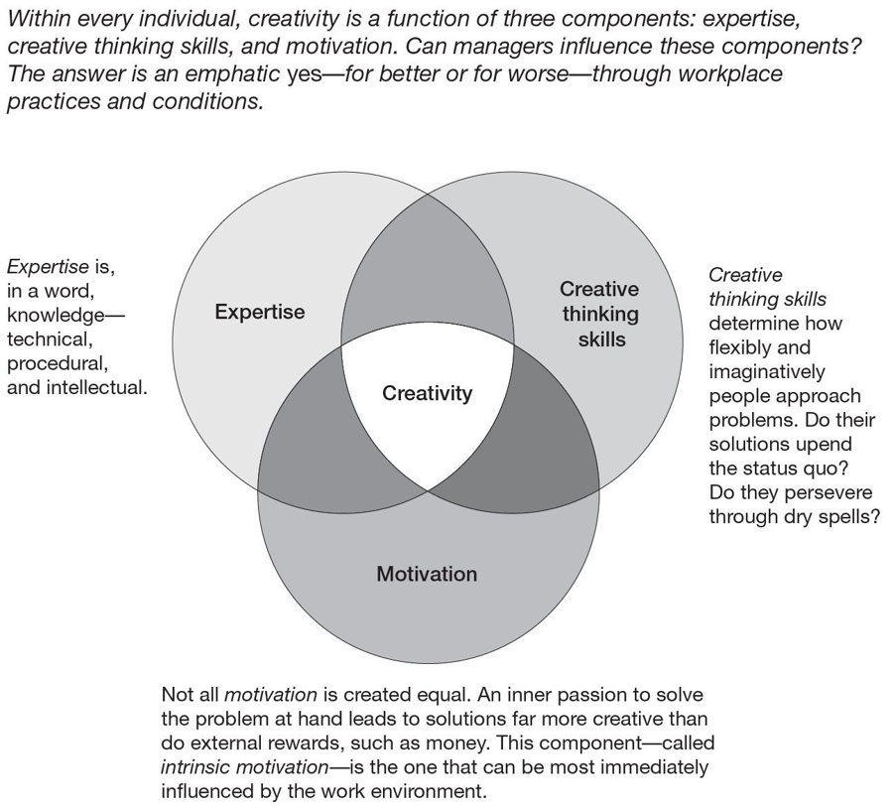Figure 11-1

### **Expertise**

Expertise is technical, procedural, and intellectual knowledge—the know- how that often takes individuals years to accumulate. Expertise is usually the product of substantial preparation, a period of time during which peo- ple look at problems or possibilities from many angles, “sleep” on them, experiment with them, develop a thorough understanding of the existing literature, and so forth. One advantage of creative teams over creative indi- viduals is that teams can bring together the many forms of expertise need- ed to solve a large problem.

### **Creative Thinking Skills**

Creative thinking skills are defined as how people approach problems. Ac- cording to Amabile, creative thinking skills are often a function of personality and work style. “The pharmaceutical scientist,” she writes, “will be more creative if her personality is such that she feels comfortable dis- agreeing with others.”⁵ It will also help if her work style is one that doggedly pursues solutions, even in the face of disappointing setbacks. The literature of invention is rich with stories of people who would not give up, but would stubbornly (almost obsessively) work at a problem de- spite repeated failures and the interference of higher-ups. Perhaps no better example can be found than the story of John Harrison, who labored al- most forty years during the eighteenth century to develop a ship-borne clock capable of keeping accurate time despite rolling waves, dramatically shifting temperatures, and changing humidity. As told by science writer Dava Sobel in her best-seller, *Longitude*, Harrison had to fight through both technical challenges and countless roadblocks set up by competitors and naysayers in the scientific community of the day.⁶ But his decades of dogged focus led to success and to a practical solution to a problem that had vexed mariners and scientists since ancient times: determining longitude at sea.

### **Motivation**

Motivation may be extrinsic or intrinsic, according to Amabile. Extrinsic motivation is induced from the outside through means such as bonuses and promotions. Her research shows that intrinsic motivation—that is, motivation fired by an internal passion or interest—has a greater impact on creativity.⁷  The power of intrinsic motivation is confirmed by the many examples we see of engineers and scientists who continue to pursue solutions long after their bosses have cut off their funding (rewards) and told them to give it up and move on. Many of these creative spirits do this at substantial personal risk, going “underground” and supporting their work through clandestine resource channels.  A classic example of a motivated innovator can be found in the story of Dick Drew, the legendary 3M inventor of the 1920s and 1930s. Drew had seen a market opportunity for an adhesive-backed product that would later be known as “masking tape.” After watching Drew’s many failures to create the right combination of materials, his boss, 3M president William McKnight, told him to drop it and work on something else. Drew agreed, but secretly continued his quest, funding it with many small purchase orders that were within his authority to make but not likely to be noticed by McKnight. McKnight learned of Drew’s insubordination only when the latter presented him with a successful product prototype. Drew’s persistence paid off in a product line that has generated revenues for 3M for more than eighty years and is still going strong.

## **Managing for Greater Individual Creativity**

Given what we know about individual creativity, what can managers do to get more of it? Clearly, creativity cannot be commanded. Nothing will be accom- plished by telling employees that “The beatings will stop as soon as you be- come more creative.”  One approach is to put a stop to the many ill-considered things that man- agers do that nip creativity in the bud:

•Punishing failure

•Encouraging complacency

•Withholding resources

•Making it difficult for people to share ideas

•Discouraging diversity of thinking

•Enforcing a convergence of viewpoints, or *groupthink*

You get the idea. Common sense tells us not to do these things. If these discourage creativity, opposite behaviors and policies should encourage it.  Amabile’s three components—expertise, creative thinking skills, and motivation—likewise provide clues as to what managers can do to power up cre- ative levels. These include:

**•Recruiting creative people:**Look for people who bring substantial

expertise to the table and give others assignments and training that will increase their expertise.

**•Hiring people who have demonstrated the persistence and selfconfidence that indicate creative thinking skills:**How can you spot a cre- ative job applicant? One expert states that creative people are often in- tense. They look at a problem from many angles and take several approaches to finding a solution. Creative people, in his view, connect problems in one field with analogous problems in other fields.⁸

**•Getting the right match:**Matching the right people with the right assignments is highly motivational; it is the simplest and most effective approach to enhancing individual creativity. Effective matching is achieved when managers assign people to jobs that make the most of their expertise, their creative thinking skills, and their intrinsic motivations.

**•Giving freedom:**Amabile suggests that managers be specific about

ends, but leave the means to their employees. Doing so will make them more creative. So instead of specifying a series of steps, say “This is our goal; think about the best way to get us there.” Freedom, however, should not be absolute. Attaching reasonable deadlines and oversight is fair and part of a manager’s responsibility.

**•Providing sufficient time and resources:**People are unlikely to be at

their creative best when deadlines are arbitrary or impossible to meet. The same happens when people feel that they lack the resources to do the job well.

### **Tips for Increasing Your Own Creativity**

If you are a manager, you need to help employees and groups be more creative. But what about you? What can you do to increase your own creativity? Here are eight recommendations:

1. **Strive for alignment:**Make sure that the goals of the organization

you work for are consonant with your most cherished values. In- stead of considering jobs at which you excel, think instead about jobs that match your deeply embedded life interests. Doing so will allow you to draw on a wellspring of personal passion.

1. **Imagine an ideal situation:**Sometimes simply envisioning an

ideal situation will help you generate useful new ideas. For in- stance, if you were in charge of a service process that was slow, costly, and prone to errors, it might be useful to erase it from your mind and envision a situation in which you could deliver the same service faster, cheaper, and more reliably. Customers would be happy, and your company would save lots of money and frustration. Then ask yourself, “What could I do to create that ideal situation?” The answer might not come to you immediately, but if you assign the problem to your subconscious mind and return to it periodically, you may experience a creative breakthrough.

1. **Pursue some self-initiated activity:**Choose projects where your

intrinsic motivation is high. If you have always loved graphic de- sign, for example, try to determine why the packaging for one of your company’s products leaves customers cold.

1. **Immerse yourself in the problem or challenge:**Instead of looking

at a problem from the outside, dive into it. Experience the problem directly—for example, by assuming the position of a customer or user of an existing product or service. Doing so will help you to understand the problem and possible creative solutions from many angles—many that you might not have anticipated.

1. **Tinker with the problem:**This will help you to better understand

the problem and the strengths and weaknesses of the potential solution. For example, if you aimed to develop a faster sea kayak, you would learn a great deal by trying out existing models, experimenting with small-scale hull shapes, and so forth. As solutions present themselves, however, resist the temptation to grab onto any one of them prematurely.

1. **Be open to serendipity:**Develop a bias toward action and toward

trying new ideas. For instance, if an accident or failure occurs while you’re prototyping a new LCD screen, don’t dismiss it too quickly. Study it for the learning opportunity that may lie within. Each day, write down what surprised you and how you surprised others.

1. **Diversify your stimuli:**Intellectual cross-pollination can get you

thinking in new directions. Develop cross-functional skills: rotate into every job you are capable of doing. Get to know people who may spark your imagination. Become a lifelong learner: take classes not related to your work. Bring your insights from outside interests or activities to bear on your workplace challenges.

1. **Create opportunities for informal communication:**Take advantage

of opportunities to exchange ideas and challenges with col- leagues. One of them may have an insight that has eluded you. Creative thought often happens during spontaneous interactions between individuals. Such interactions, however, are only useful if real communication occurs. You must find ways to encourage and facilitate communication that is appropriate for the creative environment.

### **Summing Up**

This chapter addressed the subject of creativity and individual creativity. It began with a practical definition and offered a four-stage process for how creativity works. This process includes preparation, incubation, illumination, and verification. It then exploded several myths about creativity. Contrary to conventional thinking:

•Intelligence and creativity are only weakly correlated.

•Age is not a clear predictor of creative potential.

•Calculated risk taking and the ability to think in untraditional ways play roles in creativity.

•A high percentage of important inventions are products of collaboration effect.

•Managers can make a difference in creativity output—they can create the conditions that make creativity more likely to occur.

Next, creativity was shown to have three components that you should bring to your organization’s problems:

*•Expertise*in terms of technical, procedural, and intellectual knowledge

*•Creative thinking skills*, as revealed by how people approach problems

and

*•Motivation*, both intrinsic and extrinsic.

 Finally, the chapter identified practical things you can do to manage for greater individual creativity.  Individual creativity is always an important aspect of innovation. However, organizations accomplish most of their goals through teams or groups. What are the characteristics of creative groups? How can they be managed to greater productivity? These are the key issues addressed in the next chapter.

# **Working Through Creative Groups**

*The Power of Numbers*

**Key Topics Covered in This Chapter**

*•Characteristics of creative groups*

*•Handling conflict in groups*

*•The effect of time pressure on creativity*

 WHILE CREATIVITY IS sometimes an individual act, many innovations are products of creative groups. The transistor developed by scientists at Bell Labs is just one example. Groups can often achieve greater creative output than individuals working alone because they bring a greater sum of competencies, insights, and energy to the effort.

## **Characteristics of Creative Groups**

In order to reap greater output, groups must have the right composition of thinking styles and technical skills. The “right” composition, in most cases, means a diversity of thinking styles and skills. Diversity has several benefits:

* Individual differences can produce a creative friction that sparks new

ideas.

* Diversity of thought and perspective is a safeguard against

*groupthink*—that is, the tendency of individual thought to converge for social reasons around a particular point of view to the exclusion of other views.

* Diversity of thought and skills provides opportunities for ideas to develop. An electrical engineer, for example, may seek a way to solve a technical problem while another engineer with manufacturing or mate- rials experience may enhance the solution by suggesting ways that would make the end product less costly to produce.

Thus, managers must consider how work groups are staffed and how they communicate.  A creative group exhibits paradoxical characteristics. It shows tendencies of thought and action that we’d assume to be mutually exclusive or contradictory. For example, to do its best work, a group needs deep knowledge of subjects relevant to the problem it’s trying to solve, and a mastery of the processes involved. At the same time, however, the group needs fresh perspectives that are unencumbered by the prevailing wisdom or established ways of doing things. Often called a “beginner’s mind,” this is the perspective of a newcomer: a person who is curious, even playful, and willing to ask any- thing—no matter how naive the question may seem—because she doesn’t know what she doesn’t know. Thus, bringing together contradictory characteristics can catalyze new ideas. (See “Signs That Your Group Lacks Diversity” to help you evaluate your team.)

Figure 12-1 describes a number of seemingly contradictory characteristics that a group must have to maximize its creative potential. Many people mistakenly assume that creativity is a function of only the elements in the left column: the beginner‘s mind, freedom, play, and improvisation. But a blend of the left *and*the right columns is needed. This paradoxical combination is confusing and disturbing to managers who feel a need for order and linear activity. Accepting this paradox is the first step toward success.

### **Signs That Your Group Lacks Diversity**

If you’re a manager, you’ll know that your group lacks the diversity it needs to be its creative best if you observe one or more of the following:

* Members are reluctant to disagree with each other.
* The group has been working together for more than three years

without infusions of new people

* Members converge on plans and solutions very quickly and with little discussion.
* You suspect that minority opinions are not being heard.
* People regularly defer to a single person.

### **The paradoxical characteristics of creative groups**

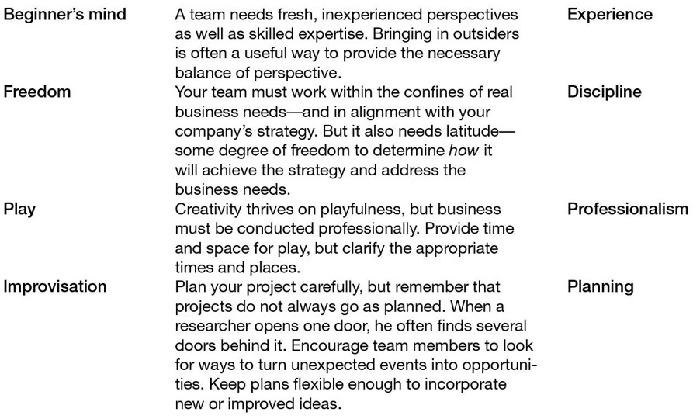Figure 12.1

## **Divergent and Convergent Thinking**

Group creativity is also enhanced when both *divergent*and *convergent*thinking are at work. These terms were coined by psychologist J. P. Guil- ford, who conducted substantial research on creativity. In his lexicon, divergent thinking is the ability to find unique and original solutions and to consider problems in terms of multiple solutions—not just one. He viewed divergent thinking as a key component of creativity. Convergent thinking, on the other hand, narrows many possible solutions to one. In other words, thought patterns converge on a single, optimal solution.

The creative process is fueled by *divergent thinking*—a breaking away from familiar or established ways of seeing and doing. This seems intuitively obvious. If we continually observe an object from the same vantage point and in the same lighting conditions, we are bound to have the same impression of that object. If we change the lighting or the viewing angle, however, our perceptions may change. They will become more complete—more nuanced. For example, if you looked at the full moon through a small telescope, you would see a flat, bright, meteor-pocked surface with a modest number of striking terrain features. Look at it again a week or so later, when the moon’s phase has created contrasts of sunlight and shad- ow, and you’ll see something very different: rugged mountains, gaping crevices, and deep craters that were barely noticeable before. The different perspective created by light and darkness makes this possible.

### **Tips for Improving Convergent Thinking**

Work groups are often tempted to converge quickly on what appears to be a single best solution and cut off future debate. It’s the team leader or manager’s job to prevent both. Consider these suggestions:

* Insist on an incubation period during which people can experiment with the various options. Some options will seem less promising after people have thought about them for a week or two.
* Appoint an official devil’s advocate to challenge all assumptions associated with the group’s favored options. That person should be respected and seen as objective.
* Ensure that dissent is tolerated and protected and that dissenters have the freedom to voice contrary views, otherwise groupthink may take control of future decisions.

Seeing things from unfamiliar perspectives makes it possible to develop insights and new ideas. But are those insights valuable? That’s what *conver- gent thinking*attempts to answer. It helps to channel the results of divergent thinking into concrete products and services. As new ideas generated by divergent thinking are communicated to others, they are evaluated to deter- mine which ideas are genuinely novel and worth pursuing. That’s convergent thinking. Without it, the creative person working alone could easily pursue an idea that eats up time and resources and leads to nothing of value.

In moving from divergent to convergent thinking, a work group makes a transition *from what is novel to what is useful*. Convergence sets limits, nar- rows the field of solutions within a set of constraints. How are those constraints determined? The culture, mission, and priorities of the company and project all contribute to the answer. They help rule out options that lie be- yond the scope of the project.

Here are some questions your team might ask as it applies convergent thinking to a range of possible solutions:

* Which functions are essential (from the customer’s point of view)

and which are only “nice-to-have”?

* What criteria are determined by the company’s values? For example, Fisher-Price groups insist that any toys developed be “Mom- friendly”—since most toys are purchased by mothers.
* What are the cost constraints?
* What are the size or shape constraints
* Within what time must the project be completed?
* In what ways must the product or service be compatible with existing products or services?

## **Diverse Thinking Styles**

Beyond divergent and convergent thinking, group creativity benefits when its members approach their work with different preferred thinking styles, and when they bring a variety of skills to a common effort. A *preferred thinking style*is the unconscious way a person looks at and interacts with the world. When faced with a problem or dilemma, a person will usually approach it through a preferred thought style. And although each style has particular advantages, no one style is better than another.

There are a number of different ways of describing how people think and make decisions. For example, the Myers-Briggs Type Indicator breaks down thinking preferences into four categories, with two opposite tendencies in each category:

1. **Extravert - Introvert:**

Extraverted people look to others as the primary

means of processing information. As they get ideas or grapple with problems, they quickly bring them to the attention of others for feedback. Extraverts energize themselves through their communications with others. Introverted people tend to process information internally first before presenting the results to others. They are happiest when they can sit down alone in a quiet place and think things through, weigh pros and cons, and so forth.

1. **Sensing-Intuitive:**Sensing people tend to prefer hard data, concrete

facts—information that is closely tied to the five senses. Intuitive people are more comfortable with ideas and concepts, with the “big picture.”

1. **Thinking-Feeling:**Thinking people prefer logical processes and orderly ways of approaching problems. Feeling people are more at- tuned to emotional cues; they are more likely to make decisions based on the values or relationships involved.
2. **Judging-Perceiving:**Judging people tend to prefer closure—they like

having all the loose ends tied up. By contrast, perceiving people like things more open; they tend to be more comfortable with ambiguity and often want to collect still more data before reaching a decision.

Don’t get hung up on the actual word used to describe any of these styles. Everyone exhibits some aspect of all eight, but they do it in varying degrees. For example, it’s not that a feeling person is incapable of logical thought; rather, it’s that his thinking about a decision tends to be more guided by the emotional impact of that decision on key relationships.

Well-balanced work groups include representatives of these different preferred thinking styles. How well-balanced are your work groups?

## **Diversity of Skills**

Once you’ve assessed how the thinking styles of your group members complement (or duplicate) each other, you’ll have a pretty good feel for whether any gaps exist. It is then time to survey the skills represented on the team. If the team lacks vital technical skills or expertise, it will have trouble developing the ideas it generates. For example, when Thomas Edi- son began thinking about producing the incandescent electric lamp, he knew that he would have to do lots of experimenting with designs and materials. So, he created a team that included technicians with machining, laboratory, and glass-blowing skills. Their skills made it possible for Edi- son to test hundreds of filament materials in rapid succession. Eventually, a vacuum bulb containing a carbonized cotton filament proved service- able. But more experiments with materials were needed before his idea could be commercialized. Again, the technical skill set he assembled made it possible to quickly perfect his “electric lamp” to the point where it would be commercialized.

In some cases, you may have to look outside your company—or industry—to find the technical know-how you need. For example, when engineers at a ceramics manufacturer experienced problems with getting ceramics to release from their molds, they realized that their problem had to do with quick-freezing—not with ceramics. So instead of seeking out other ceramics experts, they turned to food industry experts, who had special knowledge of quick-freezing.

Generally, you know that it’s time to look outward for solutions when a group has been working for a long time on a problem without success. The same applies when team members always agree or always disagree on what should be done.

### **Tips for Filling Team Gaps**

As you seek skills/knowledge diversification:

* Look for people whose intellectual perspectives complement—but don’t duplicate—your own preferred styles and skills, and those of your group.
* Look for a balance of expertise and personal characteristics (such as initiative, ability to get along with others, etc.) in each new hire.
* Look for people who can work across functional boundaries.
* When you specify hiring criteria, put a premium on finding the skills

that the group currently lacks. Don’t simply list a standard set of skills.

* Explore non-traditional hiring channels—that is, channels other than

those used by your company’s human resources department.

* Consider adding a customer or outside professional to the group. Either will bring a much different perspective. Xerox engineers, for example brought in anthropologists to help them design more user-friendly copiers.

Remember too that if your goal is to create change within the group, hiring one person who has a different perspective is insufficient. A lone hire with a different outlook may soon feel isolated and ineffective. For different thinking styles to make a difference, two things must happen: you must hire a critical mass of these people, and those people must be thoroughly integrated into the team.

## **Conflict in Groups—and How to Handle It**

Although diversity of thinking and skills is valuable, it’s not without hazards. Dif- ferent thinking styles do not produce unbroken harmony—you would not want it in any case. Expect disagreement and clashes. The manager’s job is to make conflict positive and creative.

For creative conflict to work, group members must listen to each other, be willing to understand different viewpoints, and question each other’s assumptions. At the same time, managers must prevent that conflict from becoming personal or from going underground where resentment can simmer. The best antidote to destructive conflict is a set of group norms for dealing with it. What should your group’s oper- ating norms be? Here are a few examples. You might call them the “Group Code of Conduct.”

* Every group member should show respect to others.
* Every member should make a commitment to active listening.
* Everyone has a right to disagree and an obligation to challenge others’ assumptions.
* Everyone shall have an opportunity to speak.
* Conflicting views are an important source of learning.
* Ideas and assumptions may be attacked but individuals may not
* Calculated risk taking is good.
* Failures should be acknowledged and examined for their lessons.
* Failures should be acknowledged and examined for their lessons.
* Successes will be celebrated as a group.

Whatever norms your group adopts, make sure that all members have a hand in creating them—and that everyone is willing to abide by them.

## **Three Steps for Handling Creative Conflict**

Even with consensus on norms of behavior, conflict is a fact of life in groups. The following three steps will help you turn that conflict into an active asset.

1. **Create a climate that makes people willing to discuss difficult issues:**

Help your team understand the concept of “the moose on the table” (the big issue or problem that is impeding progress but which no one wants to discuss). Make it clear that you *want*the tough issues aired, and that *anyone*can point out a moose.

1. **Facilitate the discussion:**

How do you deal with a moose once it has

been identified? Use the following guidelines:

* First, acknowledge the issue, even if only one person sees it.
* Refer back to group norms on how people have agreed to treat each other.
* Encourage the person who identified the moose to be specific.
* Keep all discussion impersonal. The point is not to assign blame —discuss *what*is impeding progress, not *who*.

If the issue involves someone’s behave who identified the problem to explain how the behavior affects him or her, rather than make assumptions about the motivation behind the behavior. For example, if someone is not completing work when promised, you might say, “When your work is not completed on time, the group is unable to meet deadlines,” not, “I know you are not really excited about this product.”

If someone is not providing necessary leadership, you might say, “When you don’t provide us with direction, we spend a lot of time trying to second-guess you, and that makes us unproductive,” not, “You don’t seem to have any idea what we should be doing on this project.”ior, encourage the person

1. **Move toward closure by discussing what can be done:**

Leave with some concrete suggestions for improvement, if not a solution to the problem. If the subject is too sensitive and discussions are going nowhere, con- sider adjourning your meeting until a specified later date so that people can cool down. Or consider bringing in a facilitator.

## **Time Pressure and Group Creativity**

Time is one of the things that every creative individual and creative group must have to achieve anything worthwhile. Radical innovations, as we’ve seen, often take ten or more years to emerge from the idea factories of research scientists. Incremental innovation of complex products such as new aircraft and new passenger cars often requires three to five years of development. Given these observations, how much time do creative people need? How much time should managers give them? These are important questions for managers as they attempt to meet organizational goals with limited resources.

Academics have studied the time pressure–creativity connection for a long time. In general, these studies point to a curvilinear relationship between the two—that is, to a certain point, pressure helps. But beyond that point, pressure has a negative impact. Teresa Amabile, Constance Hadley, and Steven Kramer continued that research, reaching some eye-opening conclusions. They point to instances where ingenuity flourishes under extreme time pressure—just as managers have always believed (or hoped!). They point, for example, to a NASA team that within hours came up with a crude but effective fix for the air filtration system aboard Apollo 13—a creative solution that saved the mission and its crew. On the other hand, they point to the Bell Labs teams that felt no such pressure; that team, nevertheless, created the transistor and the laser, which open the door to a cornucopia of innovative products.

After studying over nine thousand daily diary entries of people engaged in projects demanding high levels of creativity, Amabile and her coauthors concluded that time pressure usually kills creativity: “Our study indicates that the more time pressure people feel on a given day, the less likely they will be to think creatively.”¹

That’s bad news for companies and managers, but not entirely bad. These researchers noted that time pressure affects creativity in different ways de- pending on whether the environment allows people to focus on their work, conveys a sense of meaningful urgency about their tasks, or stimulates or undermines creativity in other ways. For example, time pressure is not a creativity killer when people feel that they *are on a mission*, which is what the NASA crew undoubtedly felt.

To help managers understand when and how time pressure affects creativity, we’ve shown the four-quadrant matrix developed by Amabile and her associates in figure 12-2.

## **Finding the Right Balance in Group Tenure**

If your job is to manage a team or work group that aims to innovate, one of the many things you should pay attention to is the length of time that group members have worked together, or group tenure. Years of working together doesn’t always produce the creativity you’d expect. Beyond a certain point, the opposite is more likely. In this regard, work groups are similar to organizations and products, which have life cycles stages. Those stages are generally associated with one level of vitality or another. Consider the typical prod- uct life cycle shown in figure 12-3. Here we see what usually happens with a successful product. Upon introduction it picks up steam on the sales front (the growth stage). Eventually, growth tapers off (the maturity stage), and at some point sales go into decline. Research by Ralph Katz and Tom Allen indicates that R&D groups pass through a similar set of stages if no actions are taken to prevent it. As Katz described their findings: “[G]roup members interacting over a long time are likely to develop standard work patterns that are both familiar and comfortable, patterns in which routine and precedent play relatively large parts—perhaps at the expense of unbiased thought and new ideas.”²

Katz and Allen found that individuals who enter these groups pass through stages of varying innovation productivity. On entering an R&D group, indi- viduals first undergo a period of *socialization*, during which they spend as much time trying to understand group norms, their bosses’ expectations, and so forth as they spend on innovative work.

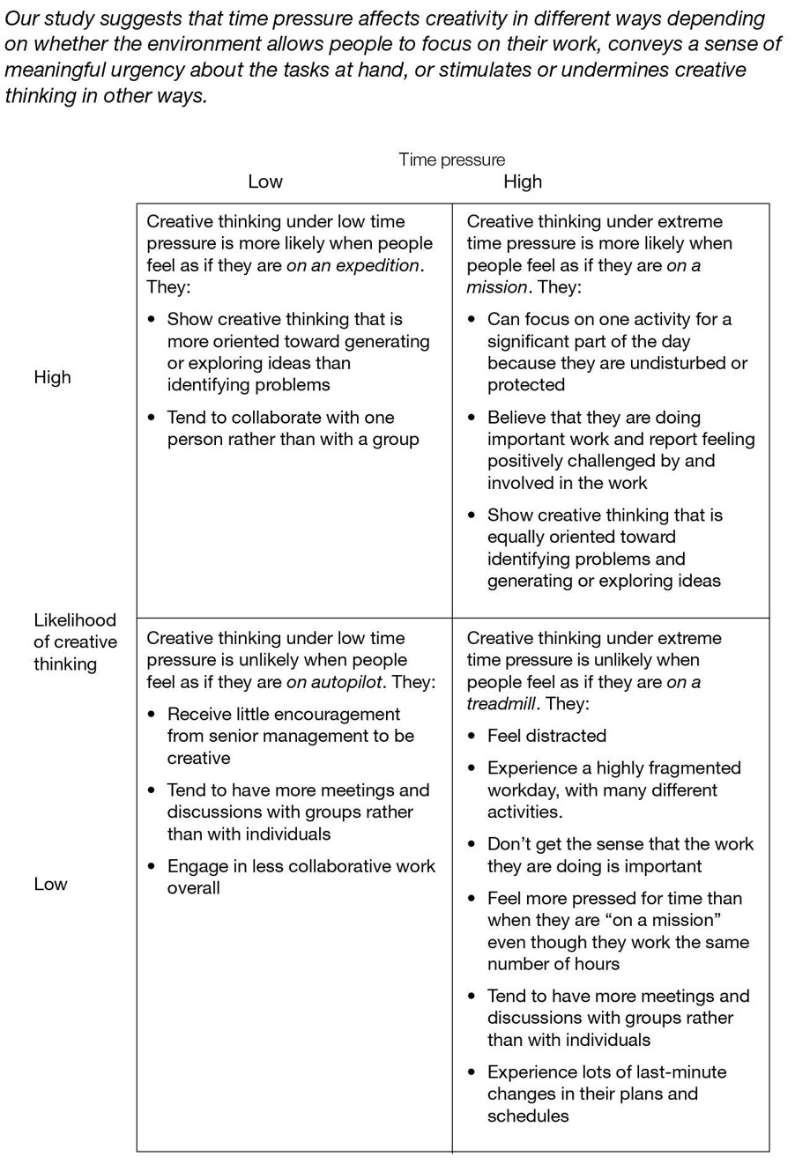

*Source:*Teresa M. Amabile, Constance N. Hadley, and Steven J. Kramer, “Creativity Under the Gun,” *Harvard Business Review,*August 2002, 56.

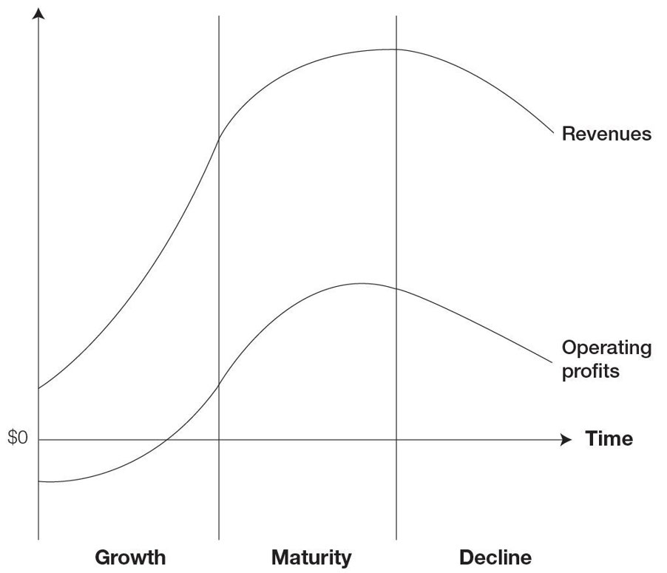

***Typical product life cycle***

The socialization stage is followed by an *innovation*period during which they are generally most productive. Individuals in this stage understand the norms of the group and where they fit in, and can concentrate on creative, innovative pursuits. After a while, however, individual group members enter a less- productive period of *stabilization.*As Katz says, “Employees who continue to work in the same overall job situation for long periods gradually adapt to such steadfast employment by becoming increasingly indifferent to the challenging aspects of their assignments.” Like most other corporate employees, these stabilized R&D workers are less absorbed with the challenges of their work and more absorbed with matters of compensation, benefits, vacations, workplace relationships, and issues with their superiors. “With stability,” Katz writes, “comes a greater loyalty to precedent, to the established patterns of behavior... employees become increasingly content with customary ways of doing things” and so forth.³ Further study indicated that tenure in the group, not chrono- logical age, had the greatest influence on creative productivity.

What solution is available to managers? Ideally, they should try to keep people in the productive *innovative*period, but how can that be done? Period- ically rotating people into other assignments, a commonplace refresher prac- tice, may not be a good solution, as it puts the employee back into the relatively unproductive socialization period. The solution, according to Katz, lies with group managers and how they supervise. He found that managers of high-performing long-tenured groups were:

Highly respected for their technical accomplishments

* Were *not*practitioners of participative management, but were more directive
* Set demanding goals
* Challenged people to work in new ways
* Had strong bases of support with senior management

Does your group have this type of leadership?

**Summing Up**

This chapter addressed the subject of creativity in individual and teams. Organizations have found that innovation is generally a function of collaboration between individuals working within groups. With that in mind, the chapter identified the characteristics of creative groups. Groups must have the right composition of thinking styles and technical skills. The “right” composition, in most cases, means a diversity of thinking styles and skills. It also means bring together some paradoxical characteristics:

* The “beginner’s mind” and experience
* Freedom and discipline
* Pay and professionalism
* Improvisation and planning

 Group creativity is also enhanced when both divergent and convergent thinking are at work:

* Divergent thinking is a breaking away from familiar or established ways.
* Convergent thinking attempts to find the value of creative insights.

The chapter also examined the issue of time pressure, which affects both individual and group creativity. Is time pressure a good thing or bad thing? Much research has been done on this issue, and the latest indicates that pressure affects creativity in different ways, depending on whether the environment allows people to focus on their work, conveys a sense of meaningful urgency about their tasks, or stimulates or undermines creativity in other ways.

Finally, the chapter noted the importance of work group tenure, and how you can keep a group from getting stale. The answer, according to two authors, was determined by management style.

# **Toward a Creativity-Friendly Workplace**

*Practical Steps*

**Key Topics Covered in This Chapter**

* *Six ways to organizational enrichment*
* *How to enrich the physical workplace*

 HIRING CREATIVE PEOPLE and posting them into well-crafted teams and work groups, as described in chapter 12, are essential steps toward producing greater creativity and innovation. The next step is more difficult and requires support at the highest levels. It involves making the organization and the work- place more supportive of creativity and innovation. Just as seeds grow best in fertile soil, the natural creativity of people is more likely to blossom within an organization whose structures, attitudes, and policies are innovation-friendly.

Even if you have put together a really hot team of creative people, that team will produce disappointing results if it’s condemned to operate within an organization that’s unfriendly to new ideas. This was precisely what people in Xerox Corporation’s Palo Alto Research Center (PARC) experienced during the late 1970s and early 1980s. PARC was (and remains) a cornucopia of innovative thinking. Its scientists and engineers had conjured up many of the technologies that would eventually power the emerging era of desktop computing: the ethernet, the mouse, and a user-friendly operating system. Xerox management, however, was not receptive to those innovations, which were not going to produce financial returns in the time frame required by the company. Many of PARC’s innovations found their way into personal computers developed by Apple.  Hewlett-Packard innovators encountered a different but equally frustrating experience around 1990. The open, decentralized organization created by founders William Hewlett and David Packard had been highly encouraging to innovators and had put the company at the forefront of many emerging product categories. But the retirement of the founders, new management, and enormous business growth resulted in a more centralized and bureaucratic organization. People with innovative ideas found that they had to gain approval from many layers of committees before they could move them forward. The result was a marked slowdown in new product introductions and plummeting profits. Thankfully, the company’s aging founders intervened, broke up the bureaucratic tangle, and returned HP to its idea-friendly ways. A huge leap in new product introductions followed—as did profits.  The Xerox and Hewlett-Packard examples underscore the impact of organi- zational practices on creativity and the innovations it produces. Table 13-1 lists the characteristics that support and encourage creativity and innovation. Con- sider these characteristics and how your company or your operating unit stands relative to them. Is it strong? Is it weak? If it’s weak, what can be done to change the situation? This chapter considers each characteristic in detail.

|  |  |  |
| --- | --- | --- |
|  | **Strong** | **Weak** |
| Risk-taking is acceptable to management |  |  |
| New ideas and new ways of doing things are welcome |  |  |
| Employees have access to knowledge sources: customers, benchmarking partners, the scientific community, and so forth |  |  |
| Good ideas find supportive executive patrons |  |  |
| Innovators are rewarded |  |  |
| Physical surroundings bring people together |  |  |

## **Risk Taking Is Acceptable to Management**

Risk aversion is normal and healthy. But progress and risk are inseparable companions. You cannot have one without the other. “You have to promote risk taking,” Es- ther Dyson told readers of *Harvard Business Review.*“Be open to experimentation and philosophical about things that go wrong. My motto is, ‘Always make a new mistake. ’ There’s no shame in making a mistake. But then learn from it and don’t make the same one again. Everything I’ve learned, I’ve learned by making mistakes.”¹  Management must recognize the risk/reward relationship and find organizational mechanisms for handling it. And it must communicate a clear understanding that reasonable risks are acceptable, since they are the companions of progress. On the innovative front, two methods are available for dealing with risk: diversification and cheap failures. These can and should be used in concert.  Diversification allows companies to spread risk over many rolls of the dice—as was made clear in the earlier chapter on portfolio management. For example, if one hundred individuals are taking calculated risks on innovative ideas, experience will generally show that some will be total failures, others will roughly break even, and some others will be very successful, producing a net positive outcome for the combined one hundred ventures. Since one can never know in advance which ideas will be the winners and which the losers, having a diversified “portfolio” of ideas in play makes sense.

Cheap failure is the second method for dealing with risk. A cheap failure is a project or experiment that is terminated with the least outlay of resources— just enough to tell managers “This isn’t going to work.” We find a direct anal- ogy to cheap failure in cardplaying. A smart cardplayer knows that he can’t ex- pect to win if he stays out of the game. So he puts down his *ante*and waits for his cards. If those cards are strong, he’ll stay in the game, matching or raising other bids. As he draws more cards, the player will decide whether staying in a particular game is worth the cost, given the odds. His goal is to get out of losing games as cheaply as possible. Smart companies treat ideas in the same way. They back promising ideas with small budgets and look for ways to test them with the least resource inputs. Like cardplayers, they quickly fold when they recognize that they have a weak or losing hand. Conversely, they increase backing for strong ideas.